**PROJECT TITLE:** Gym Management System

**DEVELOPED BY**:tanzeel khan

**PROGRAM**: BS-SE

**FRONT-END**: C# .NET

**BACK-END**: SQL SERVER 2014

**Introduction**

The project “**Gym Management system** as modernizing is taking over all the systems and digitalizing helps them improve in so many particular ways. The gym management system is one of the systems which helps the administration in speeding up the tasks at the same time reducing the complexity.

The purpose or objective of this system is to digitalize and create an automated system. The system will perform the task like adding the new member to the gym, removing the member or keeping the payments records and other stuff required in managing the gym properly.

The present scenario in the gyms is that the records are kept by writing in a file on the paper. Every management task is done manually. This creates a system unreliable and confusing to keep the correct track of the records.

The maintenance of the system like this is hardly required until it needs to change any part of the system. The information about the various things contained in the system are like members, trainers, equipment can get by just a few clicks unlike the paper documents required the serious reading for such information.

It helps in creating the various batch according to their preference or if they want a particular trainer. It made easy to generate the reports of various operations performed in the gym are like paying the fee it can be stored and later evaluated and get the list of members who did not pay the fee.

It also helps the users in reducing the carbon footprint as the amount of paper used in company reduces.

This also helps in keeping the standard width of the management system as if there is a case where the administration involves more than one person to manage the gym.

This system does not only limit itself to the administration and but also helps the members of the gym. The members can have options like attendance and fee payment change batch request etc.

This will improve the transparency between the members which is always a good quality in the system. It will also give the layer of security to the administration and the users that only authorized users can access by their credentials.

Some major takeaways:

Online registration of the member

Issuing the timetable of batch on system

Increase transparency between stakeholders

Easy payment options

Standardization of the system.

You can also check these posts

**Converting ERD to Tables**

-----------------------------------------------------

create table NewMember

(

MID int NOT NULL IDENTITY(1,1) primary key,

Fname varchar(150) Not null,

Lname varchar(150) Not null,

Gender varchar(20) Not null,

Dob varchar(100) Not null,

Mobile bigint not null,

Email varchar(150),

JoinDate varchar(100) Not null,

Gymtime varchar(120) Not null,

Maddress varchar(250) Not null,

MembershipTime varchar(120) Not null

);

INSERT QUERIES;

insert into NewMember

values('zain','khan','male','02/14/1997',03402109724,'zain81255@gmail.com','5/22/2020','3AM-6AM','gulshan-e-maymar','1 MONTH')

insert into NewMember

values('tanzeel','khan','male','02/08/1999',03473668690,'tanzeel1999@gmail.com','5/22/2020','3AM-6AM','North Karachi','3 MONTH')

-------------------------------------------------------------------------------------------------------------------

//SQL QUERY TO CREATE NewStaff TABLE

create table NewStaff

(

SID int not null IDENTITY(1,1) primary key,

Fname varchar(150) Not null,

Lname varchar(150) Not null,

Gender varchar(20) Not null,

Dob varchar(100) Not null,

Mobile bigint not null,

Email varchar(150),

JoinDate varchar(100) Not null,

Statee varchar(100) Not null,

City varchar(100) Not null

);

INSERT QUERIES;

insert into NewStaff

values('tanzeel','khan','male','02/08/1999',03473668690,'tanzeel1999@gmail.com','5/22/2020','Sindh','Karachi')

insert into NewStaff

values('Zain','khan','male','02/14/1997',03402109724,'zain81255@gmail.com','5/22/2020','Sindh','Karachi')

--------------------------------------------------------------------------------------------------------------------

create table Attendance

(

mid bigint not null,

atime varchar(100) Not null

);

-----------------------------------------------------------------------------------------------------------------------

CREATE TABLE [dbo].[users] (

[userId] INT NOT NULL,

[password] NCHAR (10) NULL,

PRIMARY KEY CLUSTERED ([userId] ASC)

);

insert into users

VALUES(9729,'1234')

insert into users

VALUES(9829,'1342')

**Conclusion**

The project has been carefully designed and efforts have been made to make the system totally error-free. It is efficient and less time consuming in nature.

**SOURCE CODE:**

**Loginform.cs**

using System;

using System.Collections.Generic;

using System.ComponentModel;

using System.Data;

using System.Drawing;

using System.Linq;

using System.Text;

using System.Threading.Tasks;

using System.Windows.Forms;

using System.Data.SqlClient;

namespace WindowsFormsApplication3

{

public partial class Form1 : Form

{

public Form1()

{

InitializeComponent();

}

private void button1_Click(object sender, EventArgs e)

{

SqlConnection con = new SqlConnection(@"Data Source=DESKTOP-6BDK8C7\SQLEXPRESS;Initial Catalog=vpl.com;Integrated Security=True");

con.Open();

int userid = Convert.ToInt16(textBox1.Text);

SqlCommand cmd = con.CreateCommand();

cmd.CommandType = CommandType.Text;

cmd.CommandText = "SELECT COUNT(*) FROM users WHERE userid='" + userid + "' AND Password='" + textBox2.Text + "'";

cmd.ExecuteNonQuery();

SqlDataAdapter da = new SqlDataAdapter(cmd);

DataTable dt = new DataTable();

da.Fill(dt);

if (dt.Rows[0][0].ToString() == "1")

{

if (userid == 1001)

{

this.Hide();

new Form2().Show();

}

else

{

this.Hide();

new Form3().Show();

}

}

else

{

DialogResult result = MessageBox.Show("Invalid username or password", "Warning", MessageBoxButtons.RetryCancel);

if (result == DialogResult.Retry)

{

this.Hide();

Form1 f1 = new Form1();

f1.Show();

}

else

{

Close();

}

}

}

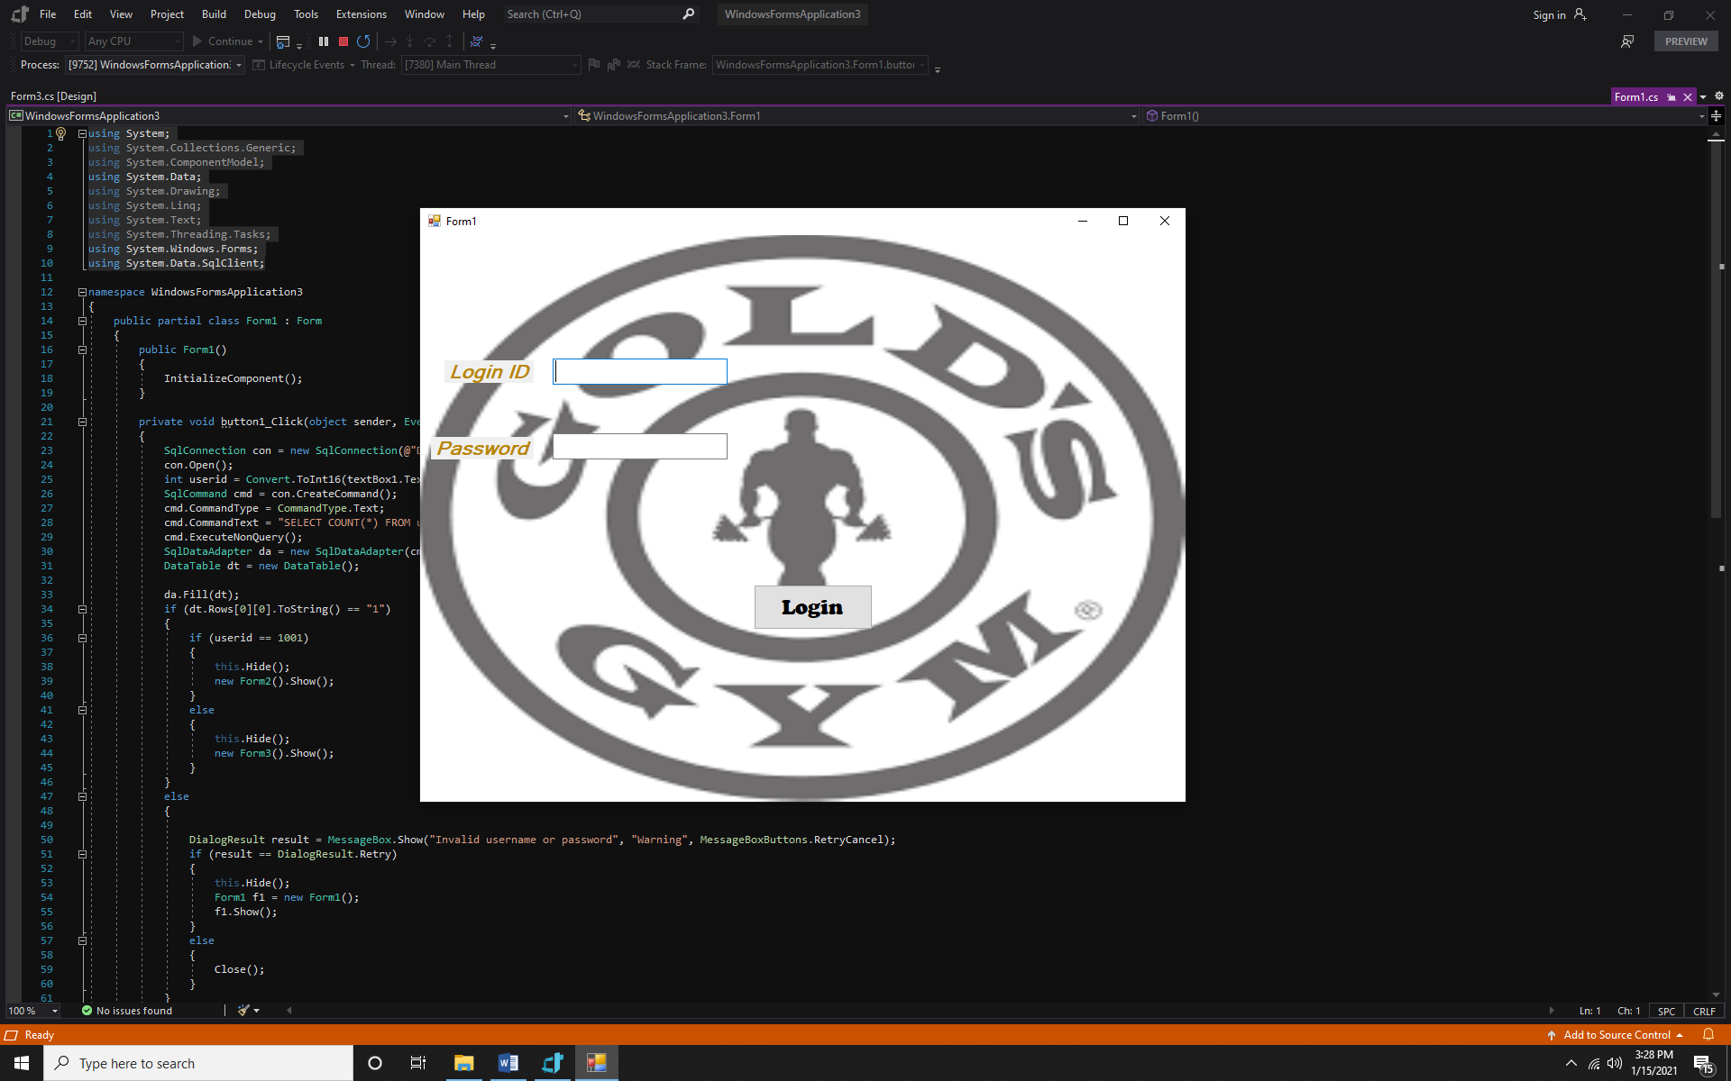

**“You enter the admin id you can see these screens in front of your pc”**

**Form2.cs**

using System;

using System.Collections.Generic;

using System.ComponentModel;

using System.Data;

using System.Drawing;

using System.Linq;

using System.Text;

using System.Threading.Tasks;

using System.Windows.Forms;

using System.Data.SqlClient;

namespace WindowsFormsApplication3

{

public partial class Form2 : Form

{

public Form2()

{

InitializeComponent();

}

private void button1_Click(object sender, EventArgs e)

{

Close();

}

private void button2_Click(object sender, EventArgs e)

{

SqlConnection con = new SqlConnection(@"Data Source=DESKTOP-6BDK8C7\SQLEXPRESS;Initial Catalog=vpl.com;Integrated Security=True");

con.Open();

int userid = Convert.ToInt16(textBox1.Text);

SqlCommand cmd = con.CreateCommand();

cmd.CommandType = CommandType.Text;

cmd.CommandText = "insert into users values ('" + userid + "','" + textBox2.Text + "')";

cmd.ExecuteNonQuery();

MessageBox.Show("Record inserted succssfully");

textBox1.Clear();

textBox2.Clear();

disp_data();

}

public void disp_data()

{

SqlConnection con = new SqlConnection(@"Data Source=DESKTOP-6BDK8C7\SQLEXPRESS;Initial Catalog=vpl.com;Integrated Security=True");

con.Open();

SqlCommand cmd = con.CreateCommand();

cmd.CommandType = CommandType.Text;

cmd.CommandText = "select * from users";

cmd.ExecuteNonQuery();

DataTable dt = new DataTable();

SqlDataAdapter da = new SqlDataAdapter(cmd);

da.Fill(dt);

dataGridView1.DataSource = dt;

con.Close();

}

private void Form2_Load(object sender, EventArgs e)

{

disp_data();

}

private void label1_Click(object sender, EventArgs e)

{

}

private void button3_Click(object sender, EventArgs e)

{

SqlConnection con = new SqlConnection(@"Data Source=DESKTOP-PGEM50J;Persist Security Info=True;User ID=sa;Password=iunc123");

con.Open();

SqlCommand cmd = con.CreateCommand();

cmd.CommandType = CommandType.Text;

cmd.CommandText = "UPDATE users SET Password = '" + textBox2.Text + "' where userid='" + textBox1.Text + "'";

cmd.ExecuteNonQuery();

MessageBox.Show("Password changed sucessfully");

textBox1.Clear();

textBox2.Clear();

disp_data();

}

private void button4_Click(object sender, EventArgs e)

{

SqlConnection con = new SqlConnection(@"Data Source=DESKTOP-PGEM50J;Persist Security Info=True;User ID=sa;Password=iunc123");

con.Open();

SqlCommand cmd = con.CreateCommand();

cmd.CommandType = CommandType.Text;

cmd.CommandText = "Delete from users where userid = '" + textBox1.Text + "'and Password= '" + textBox2.Text + "'";

cmd.ExecuteNonQuery();

MessageBox.Show("User deleted sucessfully");

textBox1.Clear();

textBox2.Clear();

disp_data();

}

}

}

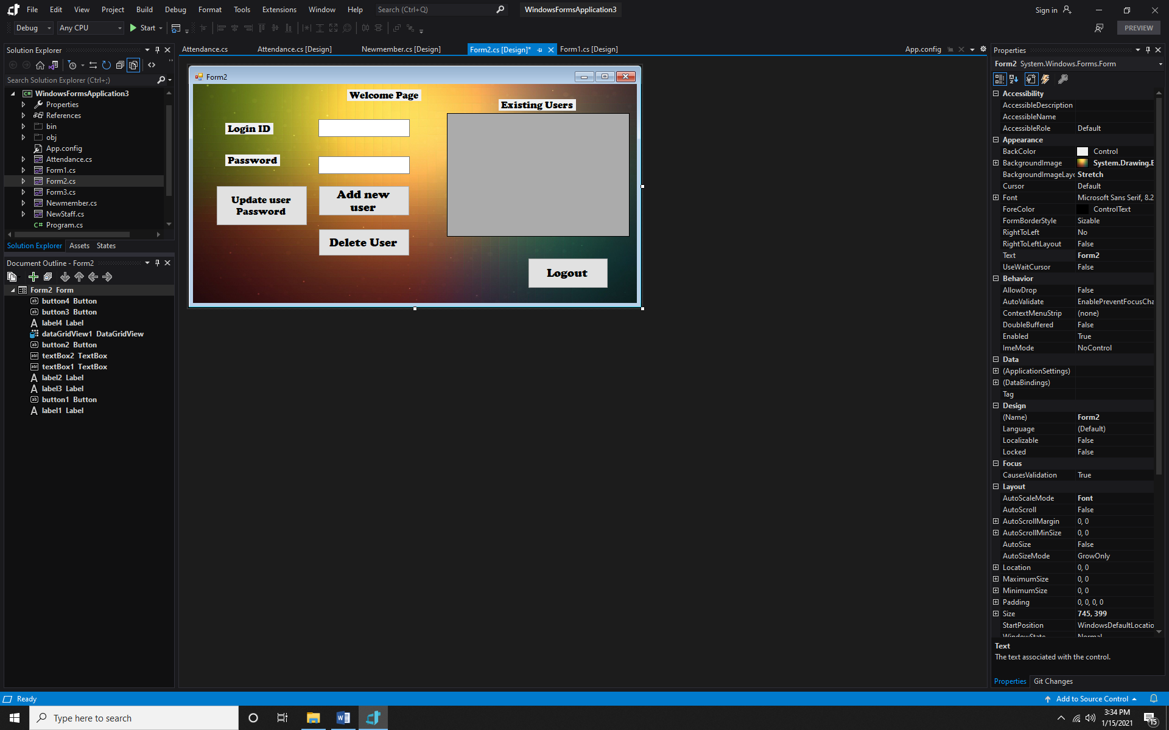

**attendanceform.cs**

using System;

using System.Collections.Generic;

using System.ComponentModel;

using System.Data;

using System.Data.SqlClient;

using System.Drawing;

using System.Linq;

using System.Text;

using System.Threading.Tasks;

using System.Windows.Forms;

namespace WindowsFormsApplication3

{

public partial class Attendance : Form

{

public Attendance()

{

InitializeComponent();

}

private void label1_Click(object sender, EventArgs e)

{

}

private void button1_Click(object sender, EventArgs e)

{

Int64 mid = Int64.Parse(textBox1.Text);

String atime = dateTimePicker1.Text;

SqlConnection con = new SqlConnection(@"Data Source=DESKTOP-6BDK8C7\SQLEXPRESS;Initial Catalog=vpl.com;Integrated Security=True");

con.Open();

SqlCommand cmd = con.CreateCommand();

cmd.CommandType = CommandType.Text;

cmd.CommandText = "insert into Attendance values('" + mid + "','" + atime + "')";

cmd.ExecuteNonQuery();

SqlDataAdapter ds = new SqlDataAdapter(cmd);

DataTable dt = new DataTable();

ds.Fill(dt);

MessageBox.Show("Data saved.");

}

}

}

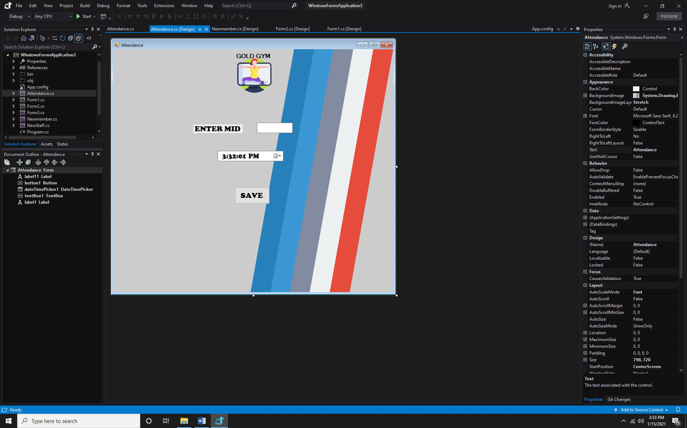

**Form3.cs**

using System;

using System.Collections.Generic;

using System.ComponentModel;

using System.Data;

using System.Drawing;

using System.Linq;

using System.Text;

using System.Threading.Tasks;

using System.Windows.Forms;

using System.Data.SqlClient;

namespace WindowsFormsApplication3

{

public partial class Form3 : Form

{

public Form3()

{

InitializeComponent();

}

private void button1_Click(object sender, EventArgs e)

{

Close();

}

private void button2_Click(object sender, EventArgs e)

{

SqlConnection con = new SqlConnection(@"Data Source=DESKTOP-6BDK8C7\SQLEXPRESS;Initial Catalog=vpl.com;Integrated Security=True");

con.Open();

SqlCommand cmd = con.CreateCommand();

cmd.CommandType = CommandType.Text;

cmd.ExecuteNonQuery();

}

private void textBox1_TextChanged(object sender, EventArgs e)

{

}

private void label3_Click(object sender, EventArgs e)

{

}

private void label4_Click(object sender, EventArgs e)

{

}

private void Form3_Load(object sender, EventArgs e)

{

}

private void newMemberToolStripMenuItem_Click(object sender, EventArgs e)

{

Newmember nm = new Newmember();

nm.Show();

}

private void newStaffToolStripMenuItem_Click(object sender, EventArgs e)

{

Newstaff ns = new Newstaff();

ns.Show();

}

private void logoutToolStripMenuItem_Click(object sender, EventArgs e)

{

Close();

}

private void searchMemberToolStripMenuItem_Click(object sender, EventArgs e)

{

Searchmember sm = new Searchmember();

sm.Show();

}

private void trainerToolStripMenuItem_Click(object sender, EventArgs e)

{

trainer ts = new trainer();

ts.Show();

}

private void atToolStripMenuItem_Click(object sender, EventArgs e)

{

Attendance at = new Attendance();

at.Show();

}

}

}

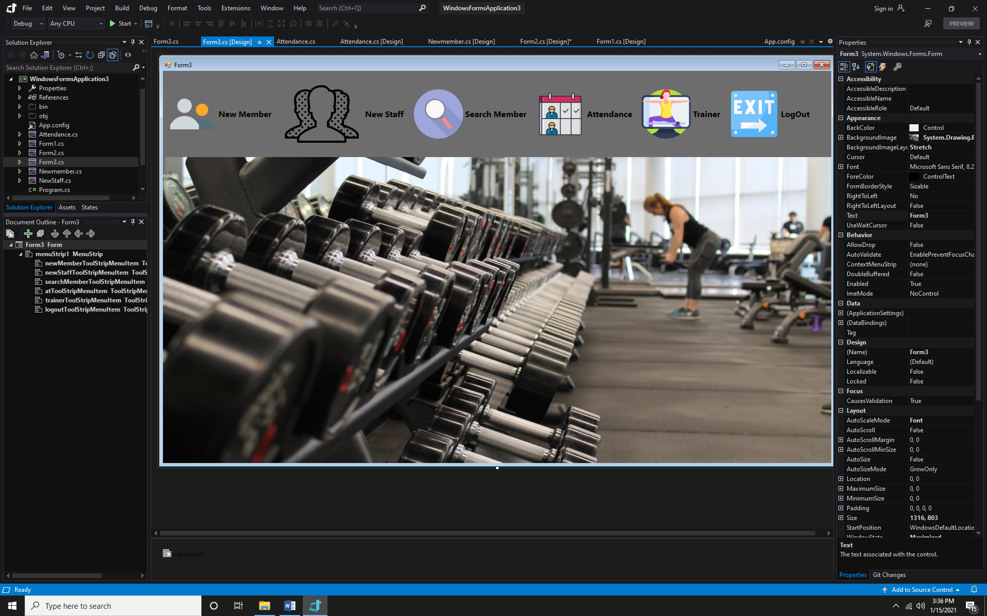

**Newmember.cs**

using System;

using System.Collections.Generic;

using System.ComponentModel;

using System.Data;

using System.Data.SqlClient;

using System.Drawing;

using System.Linq;

using System.Text;

using System.Threading.Tasks;

using System.Windows.Forms;

namespace WindowsFormsApplication3

{

public partial class Newmember : Form

{

public Newmember()

{

InitializeComponent();

}

private void Newmember_Load(object sender, EventArgs e)

{

}

private void label5_Click(object sender, EventArgs e)

{

}

private void label8_Click(object sender, EventArgs e)

{

}

private void label1_Click(object sender, EventArgs e)

{

}

private void label10_Click(object sender, EventArgs e)

{

}

private void textBox1_TextChanged(object sender, EventArgs e)

{

}

private void textBox5_TextChanged(object sender, EventArgs e)

{

}

private void label11_Click(object sender, EventArgs e)

{

}

private void button1_Click(object sender, EventArgs e)

{

String fname = textBox1.Text;

String lname = textBox2.Text;

String gender = "";

bool isChacked = radioButton1.Checked;

if (isChacked)

{

gender = radioButton1.Text;

}

else

{

gender = radioButton2.Text;

}

String dob = dateTimePicker1.Text;

Int64 mobile = Int64.Parse(textBox3.Text);

String email = textBox4.Text;

String joindate = dateTimePicker2.Text;

String gymTime = comboBox1.Text;

String address = richTextBox1.Text;

String membership = comboBox2.Text;

SqlConnection con = new SqlConnection(@"Data Source=DESKTOP-6BDK8C7\SQLEXPRESS;Initial Catalog=vpl.com;Integrated Security=True");

con.Open();

SqlCommand cmd = con.CreateCommand();

cmd.CommandType = CommandType.Text;

cmd.CommandText = "insert into NewMember values('" + fname + "','" + lname + "','" + gender + "','" + dob + "'," + mobile + ",'" + email + "','" + joindate + "','" + gymTime + "','" + address + "','" + membership + "')";

cmd.ExecuteNonQuery();

MessageBox.Show("Record has been saved in database");

con.Close();

}

private void button2_Click(object sender, EventArgs e)

{

textBox1.Clear();

textBox2.Clear();

radioButton1.Checked = false;

radioButton2.Checked = false;

textBox3.Clear();

textBox4.Clear();

comboBox1.ResetText();

comboBox2.ResetText();

richTextBox1.Clear();

dateTimePicker1.Value = DateTime.Now;

dateTimePicker2.Value = DateTime.Now;

}

private void label2_Click(object sender, EventArgs e)

{

}

private void dateTimePicker1_ValueChanged(object sender, EventArgs e)

{

}

}

}

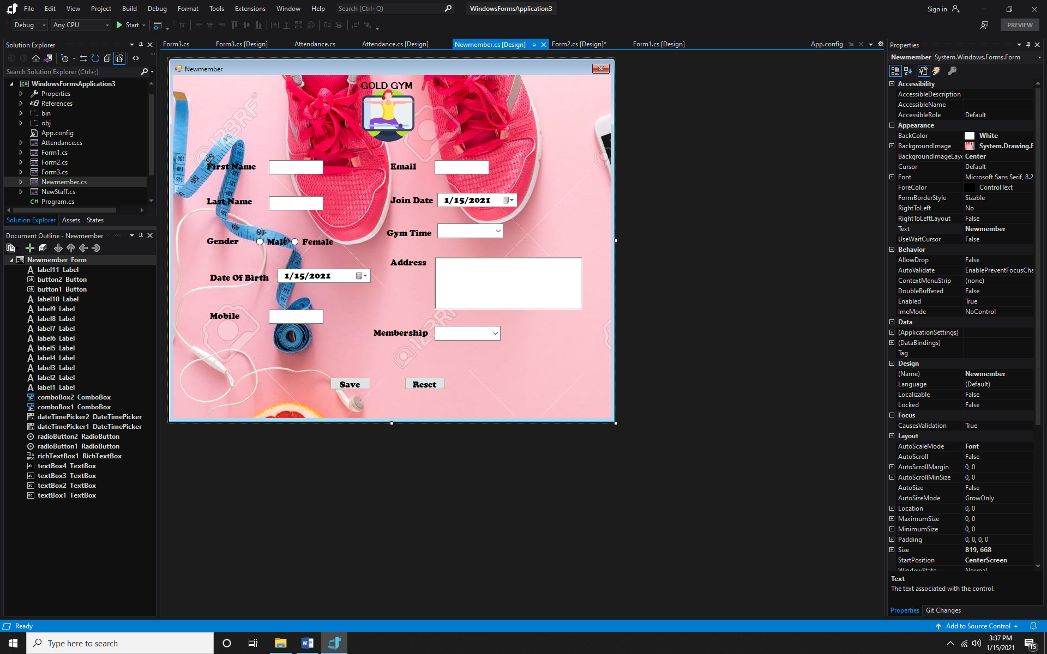

**Update_deleteform.cs**

using System;

using System.Collections.Generic;

using System.ComponentModel;

using System.Data;

using System.Data.SqlClient;

using System.Drawing;

using System.Linq;

using System.Text;

using System.Threading.Tasks;

using System.Windows.Forms;

namespace WindowsFormsApplication3

{

public partial class Newstaff : Form

{

public Newstaff()

{

InitializeComponent();

}

private void newstaff_Load(object sender, EventArgs e)

{

}

private void button1_Click(object sender, EventArgs e)

{

String fname = textBox1.Text;

String lname = textBox2 .Text;

String gender = "";

bool isChecked = radioButton1.Checked;

if (isChecked)

{

gender = radioButton1.Text;

}

else

{

gender = radioButton2.Text;

}

String dob = dateTimePicker1 .Text;

Int64 mobile = Int64.Parse(textBox3.Text);

String email = textBox4.Text;

String joindate = dateTimePicker2.Text;

String state = comboBox1.Text;

String city = textBox5.Text;

SqlConnection con = new SqlConnection(@"Data Source=DESKTOP-6BDK8C7\SQLEXPRESS;Initial Catalog=vpl.com;Integrated Security=True");

con.Open();

SqlCommand cmd = con.CreateCommand();

cmd.CommandType = CommandType.Text;

cmd.CommandText = "insert into NewStaff values('" + fname + "','" + lname + "','" + gender + "','" + dob + "'," + mobile + ",'" + email + "','" + joindate + "','" + state + "','" + city + "')";

cmd.ExecuteNonQuery();

MessageBox.Show("Record has been saved in database");

con.Close();

}

private void button2_Click(object sender, EventArgs e)

{

textBox1.Clear();

textBox2.Clear();

radioButton1.Checked = false;

radioButton2.Checked = false;

textBox3.Clear();

textBox4.Clear();

textBox5.Clear();

dateTimePicker1.Value = DateTime.Now;

dateTimePicker2.Value = DateTime.Now;

}

}

}

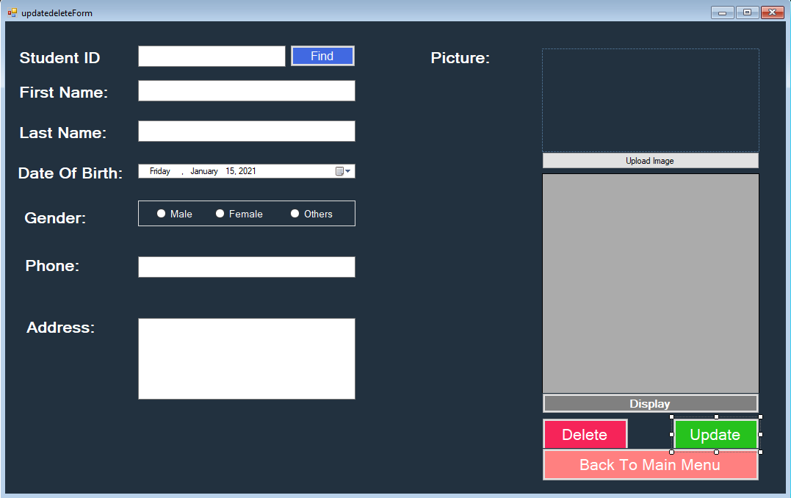

**newstaff.cs**

using System;

using System.Collections.Generic;

using System.ComponentModel;

using System.Data;

using System.Drawing;

using System.Linq;

using System.Text;

using System.Threading.Tasks;

using System.Windows.Forms;

using System.Data.SqlClient;

using System.IO;

namespace WindowsFormsApplication3

{

public partial class printForm : Form

{

public printForm()

{

InitializeComponent();

}

private void printForm_Load(object sender, EventArgs e)

{

if (radioButtonno.Checked)

{

dateTimePicker1.Enabled = false;

dateTimePicker2.Enabled = false;

}

else

{

dateTimePicker1.Enabled = true;

dateTimePicker2.Enabled = true;

}

display();

}

public void display()

{

SqlConnection con = new SqlConnection(@"Data Source=DESKTOP-TE62LBT\SQLEXPRESS;Initial Catalog=SMS;Integrated Security=True");

con.Open();

SqlDataAdapter sda = new SqlDataAdapter("select * from students", con);

DataTable dtbl = new DataTable();

sda.Fill(dtbl);

dataGridView1.DataSource = dtbl;

}

private void radioButtonyes_CheckedChanged(object sender, EventArgs e)

{

dateTimePicker1.Enabled = true;

dateTimePicker2.Enabled = true;

}

private void radioButtonno_CheckedChanged(object sender, EventArgs e)

{

dateTimePicker1.Enabled = false;

dateTimePicker2.Enabled = false;

}

private void buttongo_Click(object sender, EventArgs e)

{

SqlCommand command;

string query;

if (radioButtonyes.Checked)

{

string date1 = dateTimePicker1.Value.ToString("dd-MM-yyyy");

string date2 = dateTimePicker2.Value.ToString("dd-MM-yyyy");

if (radioButtonmale.Checked)

{

query = "select * from students where birthdate between'" + date1 + "' and '" + date2 + "' and gender= male";

}

else if (radioButtonfemale.Checked)

{

query = "select * from students where birthdate between'" + date1 + "' and '" + date2 + "' and gender= 'female'";

}

else

{

query = "select * from students ";

//where birthdate between'" + date1 + "' and '" + date2 + "'

}

command = new SqlCommand(query);

dataGridView1.DataSource = command;

}

else

{

display();

}

}

public void fillgrid()

{

dataGridView1.ReadOnly = true;

DataGridViewImageColumn piccol = new DataGridViewImageColumn();

dataGridView1.RowTemplate.Height = 80;

}

private void button2_Click(object sender, EventArgs e)

{

string path = Environment.GetFolderPath(Environment.SpecialFolder.Desktop) + @"\students_list.txt";

using (StreamWriter writer = new StreamWriter("students_list.txt"))

for (int i=0;i<dataGridView1.Rows.Count-1;i++)

{

for(int j=0;j<dataGridView1.Columns.Count;j++)

{

writer.Write("\t" + dataGridView1.Rows[i].Cells[j].Value.ToString() + "\t" + "|");

}

writer.WriteLine("");

writer.WriteLine("--------------------------------------------------------------------------");

}

MessageBox.Show("Data Exported");

}

private void dataGridView1_CellContentClick(object sender, DataGridViewCellEventArgs e)

{

}

private void button1_Click(object sender, EventArgs e)

{

this.Hide();

this.Close();

Mainform mf = new Mainform();

mf.Show();

}

}

}

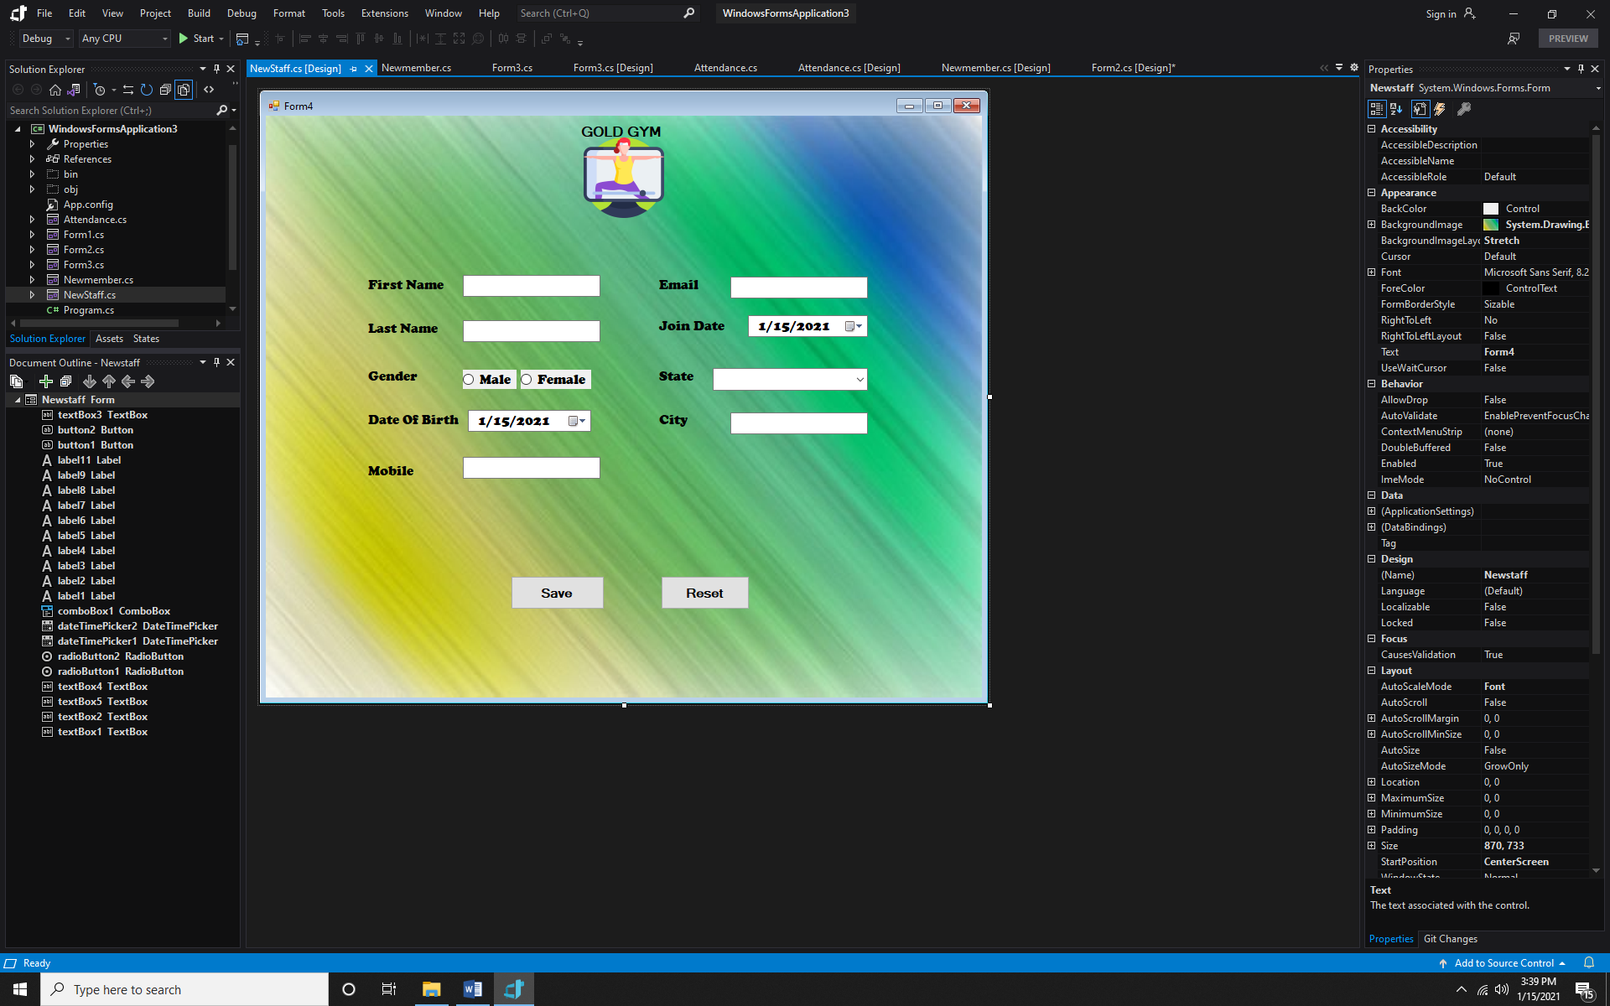

**Searchmember.cs**

using System;

using System.Collections.Generic;

using System.ComponentModel;

using System.Data;

using System.Data.SqlClient;

using System.Drawing;

using System.Linq;

using System.Text;

using System.Threading.Tasks;

using System.Windows.Forms;

namespace WindowsFormsApplication3

{

public partial class Searchmember : Form

{

public Searchmember()

{

InitializeComponent();

}

private void label11_Click(object sender, EventArgs e)

{

}

private void textBox1_TextChanged(object sender, EventArgs e)

{

}

private void Searchmember_Load(object sender, EventArgs e)

{

SqlConnection con = new SqlConnection(@"Data Source=DESKTOP-6BDK8C7\SQLEXPRESS;Initial Catalog=vpl.com;Integrated Security=True");

con.Open();

SqlCommand cmd = con.CreateCommand();

cmd.CommandType = CommandType.Text;

cmd.CommandText = "select * from NewMember ";

cmd.ExecuteNonQuery();

SqlDataAdapter da = new SqlDataAdapter(cmd);

DataTable dt = new DataTable();

da.Fill(dt);

dataGridView1.DataSource = dt;

}

private void button1_Click(object sender, EventArgs e)

{

if (button1.Text != "")

{

SqlConnection con = new SqlConnection(@"Data Source=DESKTOP-6BDK8C7\SQLEXPRESS;Initial Catalog=vpl.com;Integrated Security=True");

con.Open();

SqlCommand cmd = con.CreateCommand();

cmd.CommandType = CommandType.Text;

cmd.CommandText = "select * from NewMember where MID = '" + textBox1.Text + "'";

cmd.ExecuteNonQuery();

SqlDataAdapter da = new SqlDataAdapter(cmd);

DataTable dt = new DataTable();

da.Fill(dt);

dataGridView1.DataSource = dt;

}

else

{

MessageBox.Show("Please enter some id", "Message", MessageBoxButtons.OK, MessageBoxIcon.Warning);

}

}

}

}

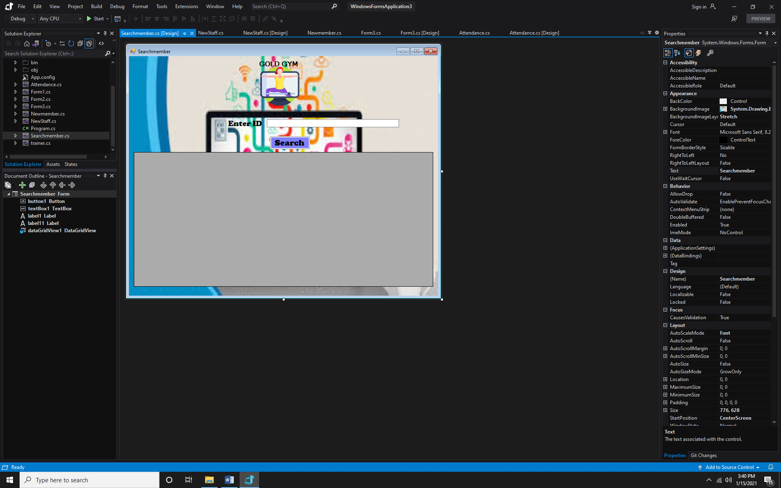

**Trainer.cs**

using System;

using System.Collections.Generic;

using System.ComponentModel;

using System.Data;

using System.Drawing;

using System.Linq;

using System.Text;

using System.Threading.Tasks;

using System.Windows.Forms;

namespace WindowsFormsApplication3

{

public partial class trainer : Form

{

public trainer()

{

InitializeComponent();

}

private void textBox1_TextChanged(object sender, EventArgs e)

{

}

}

}

